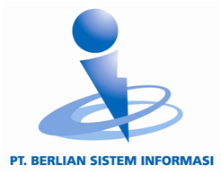

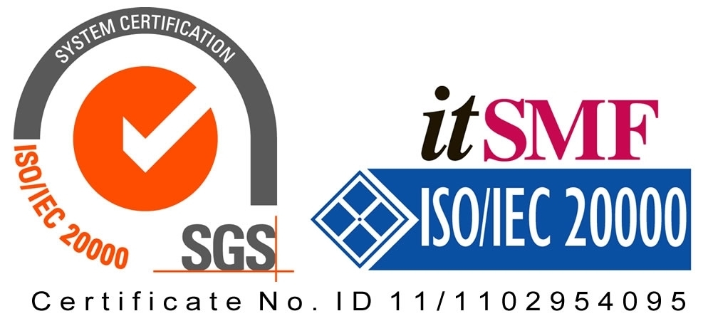

*Operating Lease Support System Development*

**For**



***Entity Relationship Diagram***

***USER ROLE MANAGEMENT***

Revision 0.0

**Prepared by:**

**PT. Berlian Sistem Informasi**

KTB Annex Bld. 4th Floor, Jl. Jend. A. Yani. Pulomas,

Tel. +62 21 4786 7575 (Hunting) Fax. +62 21 4714964 [www.bsi.co.id](http://www.bsi.co.id)

Document Control

|  |  |
| --- | --- |
| **Author** | ACHMAD FARDANI RIZKI |
| **File Name** |  |
| **Path** | N/A |
| **Create Date** |  |
| **Last Edited** |  |
| **Number of Pages** |  |

Revision History

|  |  |  |  |
| --- | --- | --- | --- |
| **Date** | **Revision** | **Description** | **Author** |
| 10-Juni-2015 | 0.0 | Initial creation | Achmad Fardani Rizki |

Table of Contents

Document Control 2

Revision History 2

1 Introduction 4

1.1 Purpose 4

1.2 Scope 4

1.3 Acronyms and abbreviations 4

1.4 References 4

2 Database Relationship And Column Properties 5

2.1 Diagram 5

2.2 Database Column Properties 6

2.2.1 User 6

2.2.2 UserRole 6

2.2.3 Role 6

2.2.4 RolePermission 7

2.2.5 Permission 7

1. Introduction
   1. Purpose

This document is addressed for the users whose have privileges for manage the OLSS Application.

* 1. Scope

This ERD is shows the relationships of entity sets, and also object of the entity.

* 1. Acronyms and abbreviations

[N/A]

* 1. References

[N/A]

1. Database Relationship And Column Properties
   1. Diagram

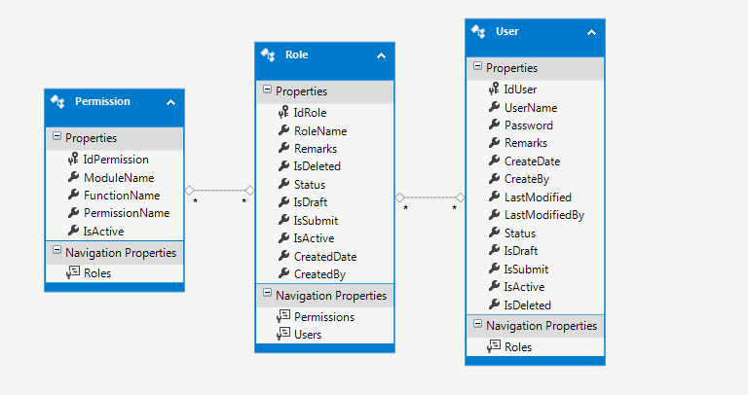

Figure 1 –diagram of User Role Management

1. Permission and Role in a many-to-many relationship, with RolePermission as linking/junction table. The link table contains just the foreign keys used to link the two tables together with no payloads.
2. User and Role in a many-to-many relationship, with UserRole as linking/junction table. The link table contains just the foreign keys used to link the two tables together with no payloads.

* 1. Database Column Properties
     1. User

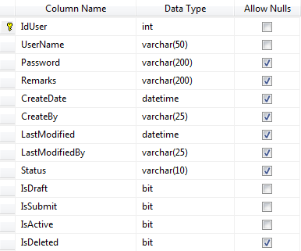

* + 1. UserRole

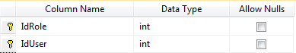

* + 1. Role

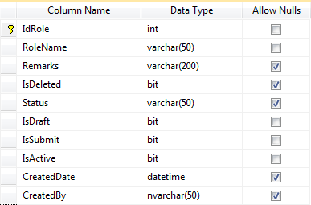

* + 1. RolePermission

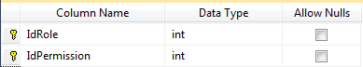

* + 1. Permission

